Exp. No: 17
EYE DIAGRAM ANALYSIS OF OPTICAL COMMUNICATION LINK USING OPTISYSTEM

OBJECTIVES
1. Design and establish a fiber optic communication link using OptiSystem
software.
2. Measure and evaluate the Bit Error Rate (BER) of the system for different fiber
lengths.
3. Study the effect of fiber length on BER, Q-factor, a=enuation, and dispersion.

SOFTWARE REQUIRED
• Optisystem software

CIRCUIT DIAGRAM

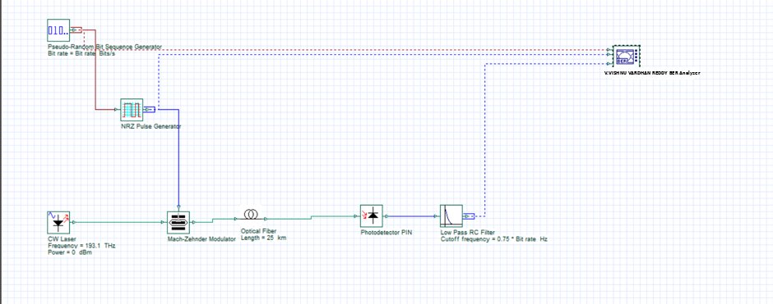

Fiber Length (25 km) 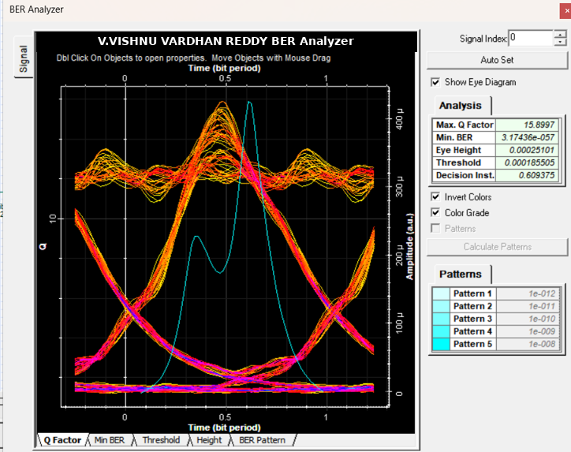
Fiber Length (50 km)
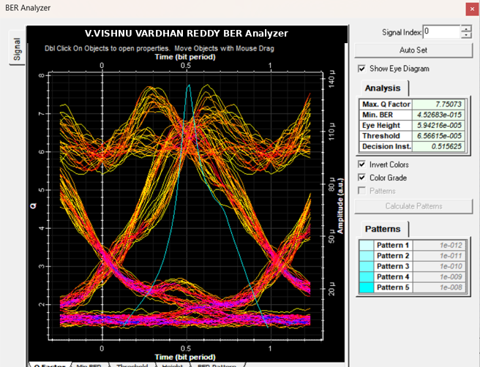

Fiber Length (75 km)
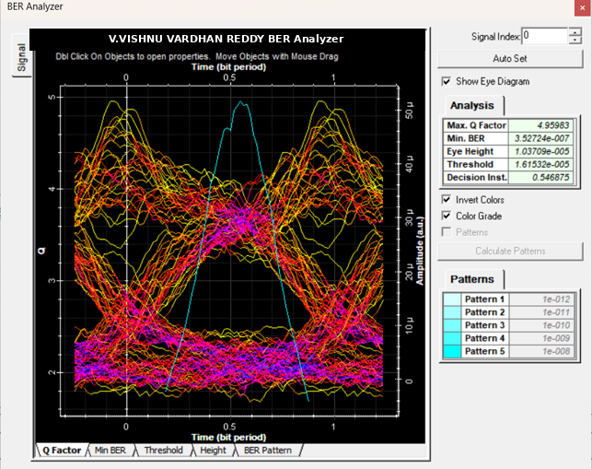
Fiber length (100 km)
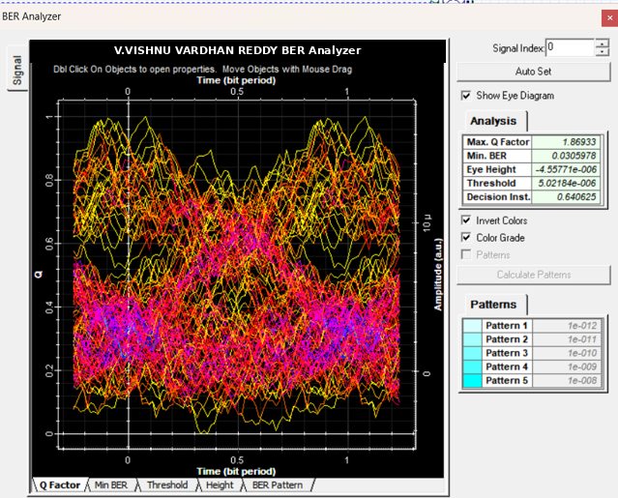
RFLECTION
- Signal Degradation: Increasing fiber length increases attenuation and dispersion, which broadens optical pulses and closes the eye diagram.
- Transmission Limit: The unamplified link remains reliable up to 50 km ($Q>6$, $\text{BER}<{10}^{-9}$), but experiences complete failure ($Q=0$, $\text{BER}=1$) at 100 km and above.
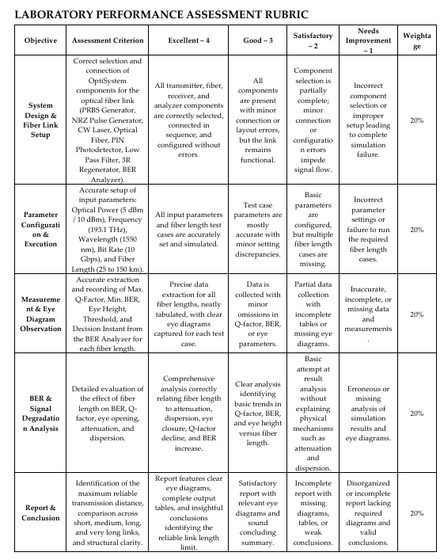

CONCLUSION:
The optical spectrum was successfully analyzed using OptiSystem. Higher source
power increased spectral intensity and caused nonlinear broadening, while longer
fiber length led to greater a=enuation and dispersion. Together, these effects increased
spectral distortion and signal degradation.

